What is xml entity

Entity is like a global variable which stores data ,

int x=10;

entity y=20 ; these both are same

DTD means document type definition starts with <!DOCTYPE>

Use case:- assume we have a big xml document, where person name is mahesh,if this is used in many places,

Then with help of entity and dtd, we can store and re-use the same content

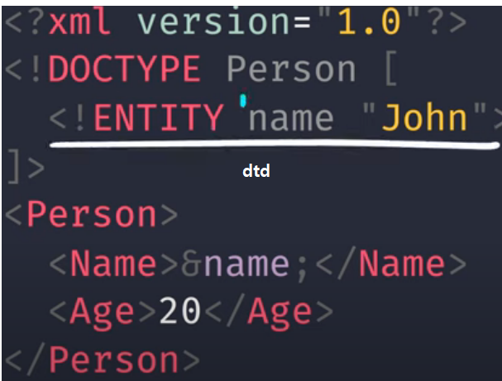

see here we are definining the name=john in above dtd, and we are re-suing those variables In entire xml document down

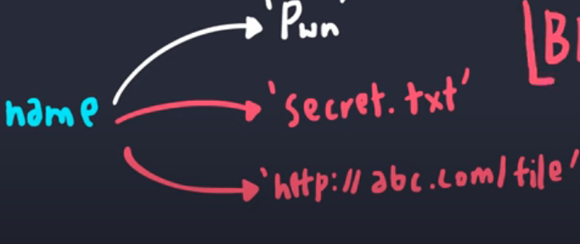

Entities can fetch data from file, even remote servers

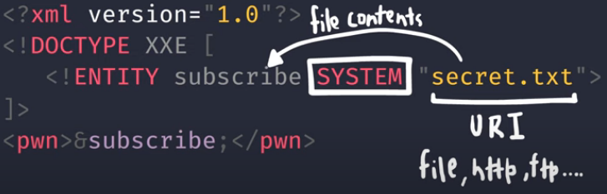

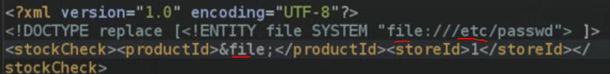

This is fetching data from file and it will store the data into variable named “subscribe”

Fetching from internet site

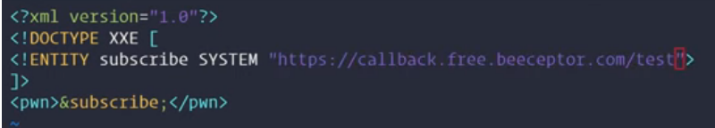

Parameter entity

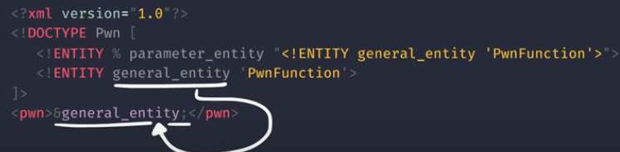

External dtd – here main xml doctype is referrin to external dtd

